

INTERNAL MEETING MINUTES

Meeting Purpose | TDWG RASD Task Group
Time and Date | 23rd March 2026, from 19:00 AEDT
Attendees | Piers Higgs  Mieke Strong  Cam Slatyer  Tania Laity  Simon Sherrin  Will Morris
Apologies | Debora Arlt  James Wilson  Andrew Rodrigues

Agenda
- Review proposed data schemas for Darwin Core Native and Darwin Core Data Package
- Discuss next steps for the Task Group

Minutes

Acknowledgement of country from Cam.

Cam outlined that the aim was to do a quick overview of the Darwin Core native and the Darwin Core data package, worth still doing for the recording and then just go through the next steps and what they are - in terms of preparing the necessary documentation for the TDWG executive.

Quick overview of Proposed Data Schemas – Mieke and Simon

Darwin Core Native

This document is in the Github repository v0.31 - https://github.com/tdwg/sensitive-species-extension/blob/main/Data%20Models/Proposed%20RASD%20extension%20for%20traditional%20DWCA%20v0.31.docx

There are two sections – the first includes a table which looks at individual fields (focusing on Occurrence – but could be applied to Event etc. There are controlled vocabularies to be used for sensitivity reasons and treatments.

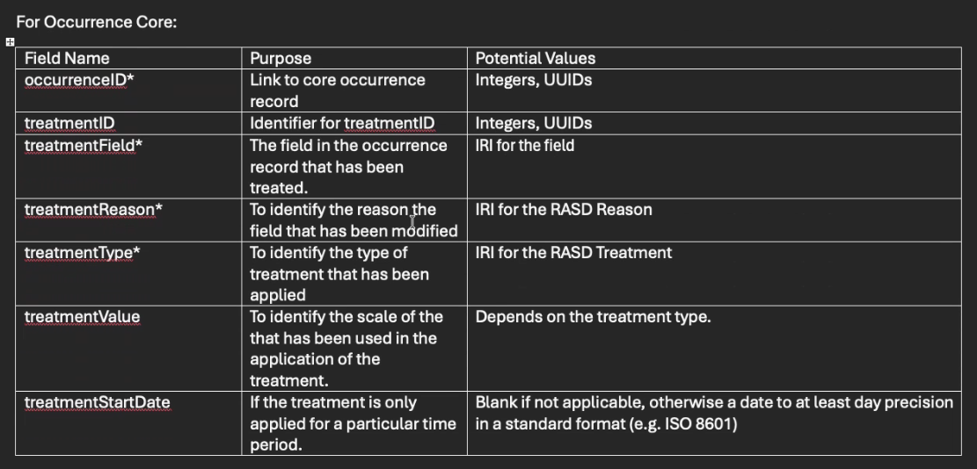
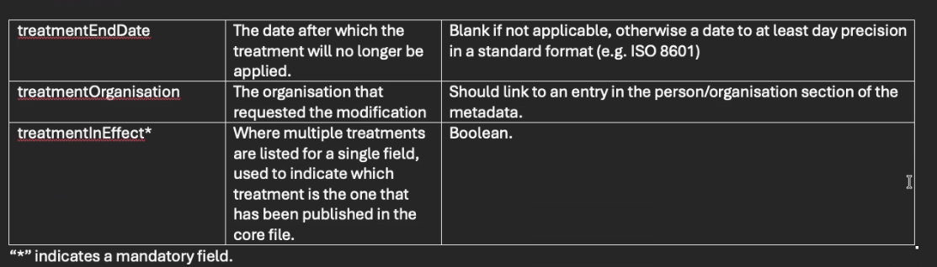

The second section gives examples of data in each of the proposed fields.
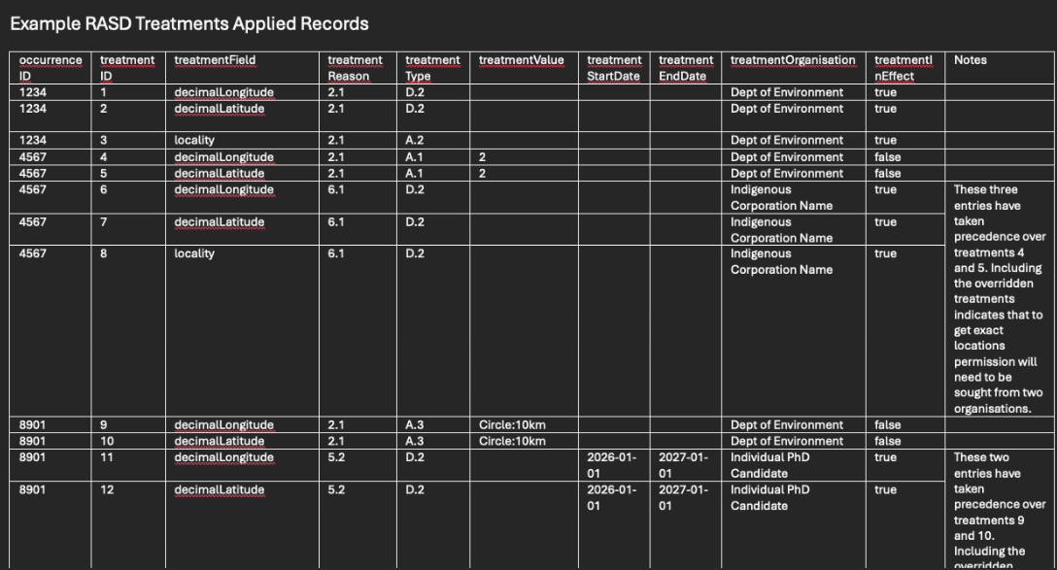

There was discussion around the inclusion of the treatmentInEffect field.

The reasoning for adding this field is where there are multiple treatments to be applied to the same record to the same attribute in that record. Generally, it will be the most strict treatment that will override others. To get the raw data you would have to go back to all of the institutions who considered the information sensitive. Another case for this field would be where the treatment is time limited – we still need to have all the other treatments which apply to that record. Meike also mentioned it could be used as a rapid filter to find out which treatment was being applied at any point in time.

There was a discussion about potentially using the treatment start and end dates but this was discounted as they often won’t have a date and it would be too hard to maintain / know when it had ended if it wasn’t specified in the first instance.

There was discussion around documenting clearly that there is a rule that the most strict treatment gets precedence.

Will raised a few questions around this column:
- Is it really necessary as the stricter treatment would generally override the others anyhow? Agreed that this would be the case
- What would you do if there were two treatments which were the same for the same record - Answer was that they could both be true at the same time
- The name of the column implies that a value of “no” implies it’s not relevant / applied. Answer – perhaps rename the column to something more intuitive – like treatmentApplied

ACTION – decide on a new name for the column and leave it in the table. Seek comments from the broader Task Group on (a) alternative names for treatmentInEffect and (b) whether it is necessary.

Note: there was general agreement in the meeting that unless there is a clear prevailing view in the broader Task Group we would retain treatmentInEffect in the documentation sent to TDWG Executive for broader commentary – make a decision on whether to remove it post review.

PH raised the point of “TreatmentEndDate” being blank - does this means the treatment is perpetual.

ACTION – Need to include clearer advice in documentation on the implications of treatmentInEffect being blank.

DWC Data Package

The proposal is that treatment is its own class and can be applied wherever you want to apply it – There will be some tables to enable the joining (would just have the identifiers between the core class and the treatments). John had mentioned at the last meeting that GBIF were concerned about the join tables idea. Andrew followed up with them and the response was that it would be good to have another strong case for them – perhaps include it in the DWC Data Package Review GitHub. Andrew was unsure if there were technical limitations as Fette was away. John had asked what other fields were to be in the join tables – it was agreed that only the primary ids from the source tables would be included.

ACTION – include use case for join tables on DWC Data Package GitHub issue.

Some discussion on relating to the agents as well - not just about the treatments but also linking to the agents as well from the treatments as well.

The process from now on (Cam)

Next Steps:
- Task Group to agree on the draft schema’s for DWC native and DWC Data Package
- Appoint a review manager – someone who has subject matter expertise but outside of the task group (if we don’t do make suggestions – the TDWG Exec will choose someone)
- Two documents need to be prepared:
- A draft human readable document - https://github.com/tdwg/vocab/blob/master/sds/documentation-specification.md (section 3)
- A draft machine readable document -https://github.com/tdwg/vocab/blob/master/sds/documentation-specification.md (section 4)
- Also need to come up with the draft vocabularies - https://github.com/tdwg/rs.tdwg.org/blob/master/process/create-vocabulary.md

TDWG Process - TDWG shows what happens next at a very high level!

This goes to TDWG executive and then if that’s all good then it goes to public consultation.

We need to give ourselves a couple of months to do this as it’s not simple. We are hoping to get a draft set completed in April and May and then reconvene as a group to make sure we’re happy with the package prior to submitting to the executive.

All agreed with this approach.

ACTION - TL and CS to help with the draft human readable document

ACTION - MS and SS to help with machine readable, along with SS (both away in late May)

ACTION - PH and WM to look at the draft vocabs (MS offered to help).
ACTION – seek assistance from the boarder Task Group
Other Business
Task Group Workshop in September
TDWG Conference in September this year and we have put in a proposal to TDWG to suggest a workshop in the margins of the TDWG meeting to access the support for travel. If we get the documentation package ready to submit to the TDWG Executive by May / June then it hopefully will be out for public consultation by September. The workshop at TDWG will be to get a group of people to look at how to implement the proposal.

Regarding the timing in the workshop we were advised to propose it to be either before or after the conference - we asked for Sunday 21st September as a provisional time. The GBIF Governing Board meeting is supposedly the week after the Conference ie 28th onwards, so we could potentially run the workshop after TDWG on the weekend ie- 26th or 27th September, to make thongs convenient for those members staying on for the GBIF meeting.

ACTION - CS will consult with the wider group regarding timing

TDWG Conference – Session Proposal
TL and CS also put in a holding meeting with Andrew and Piers to put in a session on RASD at TDWG, but that will be a normal talk-based session. If that happens, we’ll tap a range of presenters to deal with this space to talk in that conference session. This might work quite well as an advertisement for the workshop session.

TDWG Annual Working Sessions
The TDWG annual working sessions are scheduled for weeks of the 11th and 18th of May – We will probably hold 2 session – one which is more friendly for eastern and one for western hemispheres. The timing works well as it will be just after we’re finishing the draft documentation, so the working sessions are a chance to communicate to the broader community and brief them on what we’re doing and look for other members. We can look at showcasing where we’re up to with the three information packages and use it as a working meeting to go through the three drafts. Currently scheduled for the 13th May for those who are interested.

Meeting Closed: 20:15 AEDT

